I prototyped a non‑invasive DNS leak detection method using a standard web‑based DNS leak test website. The test triggers multiple DNS lookups through the browser by fetching images or resources from randomly generated subdomains.
I ran the test twice: once with VPN disconnected (normal ISP routing) and once with Proton VPN connected, then compared the observed resolvers.

Results
Test Condition | DNS Server IP(s) | Provider / ASN | Notes
VPN OFF | 73.139.77.143 | Comcast Cable | Normal ISP resolvers observed. ​
VPN ON (Proton VPN) | 10.2.0.1 | Proton VPN (private) | VPN‑owned resolvers only. No ISP servers present.

Analysis
DNS resolvers were successfully observed without privileged access (root/admin) by using a browser‑based test that leveraged the leak test site’s DNS logging infrastructure.
VPN ON/OFF behavior was clearly different: VPN OFF used ISP resolvers (Comcast), while VPN ON used Proton VPN’s own resolvers (private IP and Proton AG ASN).
No DNS leak detected in this test scenario. The VPN correctly routed all DNS traffic through its own resolvers, preventing ISP DNS exposure.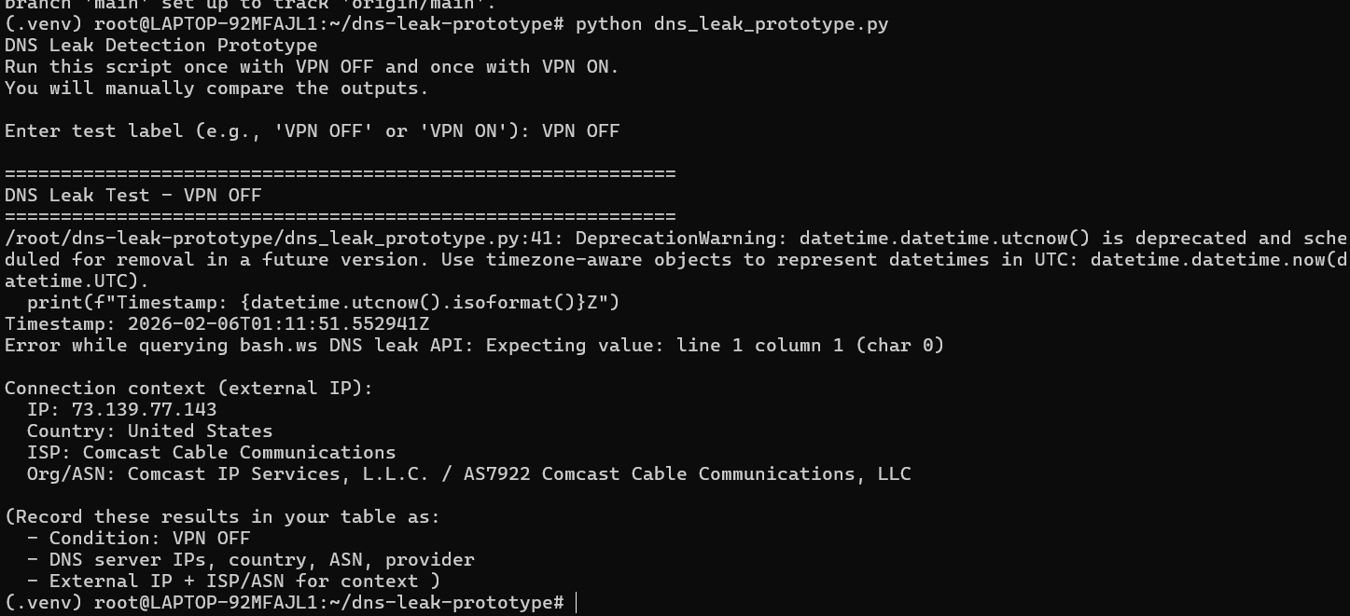

https://github.com/ajnavas09/DNS-Leak-method/blob/main/dns_leak_prototype.py

